| **Title** | 1st homework in the Python-based basic Machine learning  class by 201923250 |
| --- | --- |

| **Author** | 201923250 | **Date** | 3.26.2022 |
| --- | --- | --- | --- |

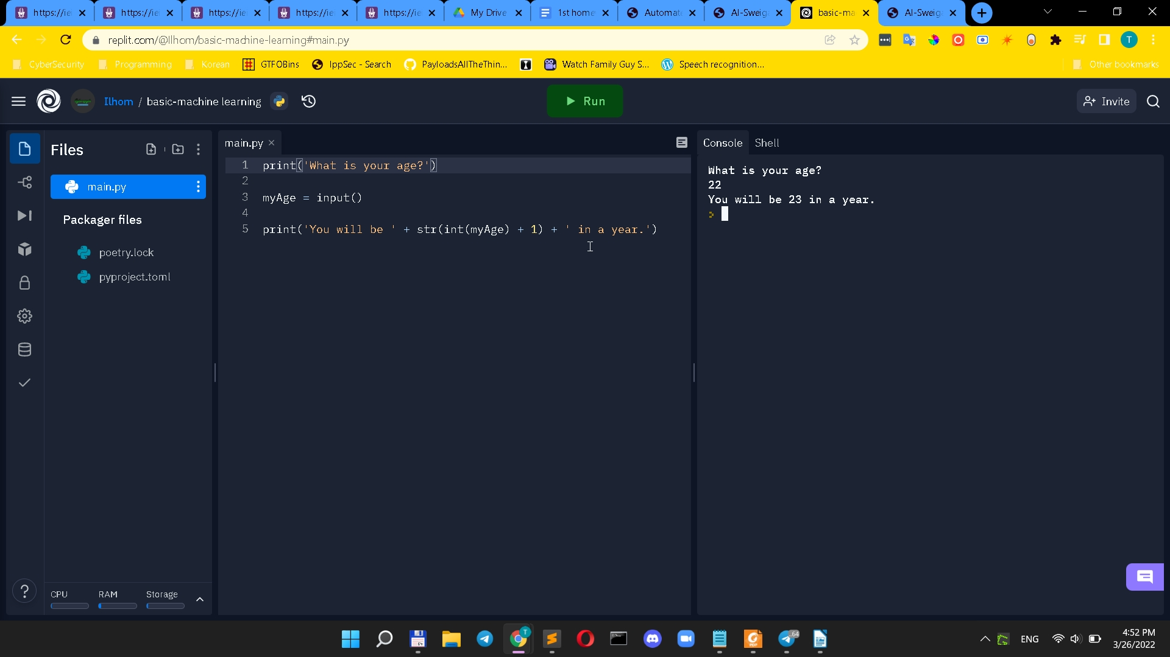

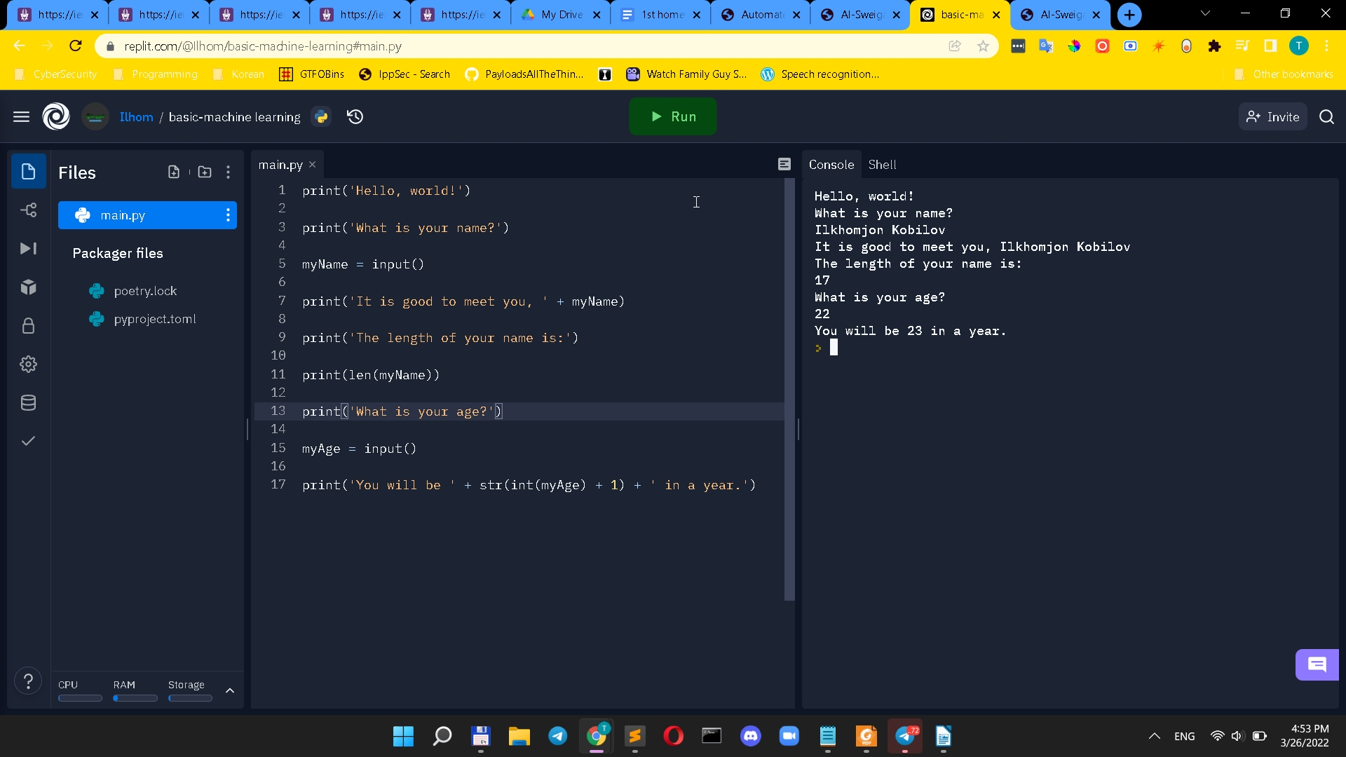

**Summarization for pages from 1 to 20**

These rules for combining operators and values to build expressions, like the grammar rules that let humans speak, are a basic aspect of Python as a programming language. The expression is reduced to a single string value that repeats the original string the specified number of times. String replication is a valuable technique, although it isn't as often used as string concatenation. A variable is a compartment in the computer's memory where a single value can be stored. You may save the result of an evaluated expression in a variable and utilize it later in your program.

A good variable name is one that accurately conveys the data it holds. "Print out the text in the string 'Hello, world!'," says print('Hello, world!'). When Python executes this line, you may say that it is executing the print() method and passing the string value to it. An argument is a value that is given to a function call. It's worth noting that the quotes aren't displayed on the screen. They only indicate the beginning and end of the string; they are not part of the string value.